**Experiment 1.4**

**Student Name:** Nabha Varshney **UID:** 20BCS4995

**Branch:** B.E.-CSE  **Section/Group:** 20BCS704-A

**Semester:** 6th **Date of Performance:** 07/03/2023

**Subject Name:** Internet of Things Lab **Subject Code:** 20CSP-358

1. **Aim:**

Program to interface the Arduino/Raspberry Pi with LED and blinking application.

1. **Objective:**

* Learn about interfacing.
* Learn about IoT programming.

1. **Requirements:**

##### 1 × Breadboard

##### 1 × Arduino Uno R3

##### 1 × LED

##### 1 × 330Ω Resistor

##### 2 × Jumper

1. **Procedure:**

LEDs are small, powerful lights that are used in many different applications. To start, we will work on blinking an LED, the Hello World of micro controllers. It is as simple as turning a light on and off. Establishing this important baseline will give you a solid foundation as we work towards experiments that are more complex.

##### **Turn on LED programmatically via Pin 5**

##### Step 1: Start a new sketch in the Arduino IDE. Start a new sketch in the Arduino IDE:

##### Step 2: Set the pinMode for Pin 5. ...

##### Step 3: Set Pin 5 HIGH. ...

##### Step 4: Compile the code. ...

##### Step 5: Upload the code to Arduino.

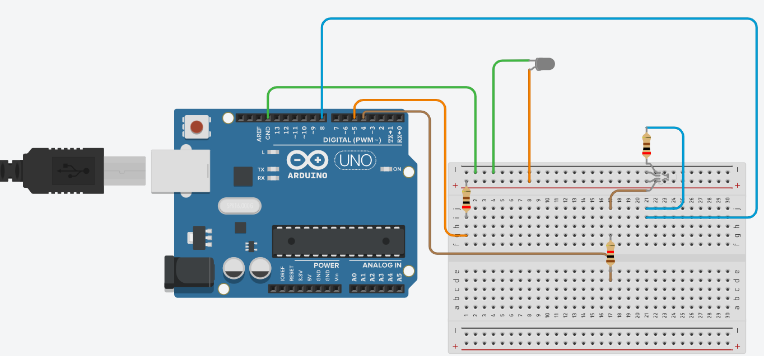

##### **Note** − To find out the polarity of an LED, look at it closely. The shorter of the two legs, towards the flat edge of the bulb indicates the negative terminal.

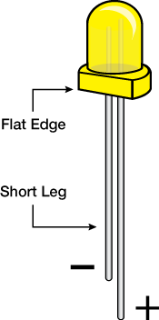

Components like resistors need to have their terminals bent into 90° angles in order to fit the breadboard sockets properly. You can also cut the terminals shorter.

##### **Sketch** Open the Arduino IDE software on your computer. Coding in the Arduino language will control your circuit. Open the new sketch File by clicking New.

##### **Sketch**

##### **pinMode(5, OUTPUT)** − Before you can use one of Arduino’s pins, you need to tell Arduino Uno R3 whether it is an INPUT or OUTPUT. We use a built-in “function” called pinMode() to do this.

##### **digitalWrite(5, HIGH)** − When you are using a pin as an OUTPUT, you can command it to be HIGH (output 5 volts), or LOW (output 0 volts).

1. **Steps/Program:**

##### void setup() { **// initialize digital pin 5 as an output.**

// put your setup code here, to run once:

pinMode(LED_BUILTIN,OUTPUT);

pinMode(5, OUTPUT);

}

##### void loop() { **// the loop function runs over and over again forever**

// put your main code here, to run repeatedly:

digitalWrite(LED_BUILTIN, HIGH);

digitalWrite(5, HIGH);

delay(10000);

digitalWrite(LED_BUILTIN, LOW);

digitalWrite(5, LOW);

delay(10000);

}

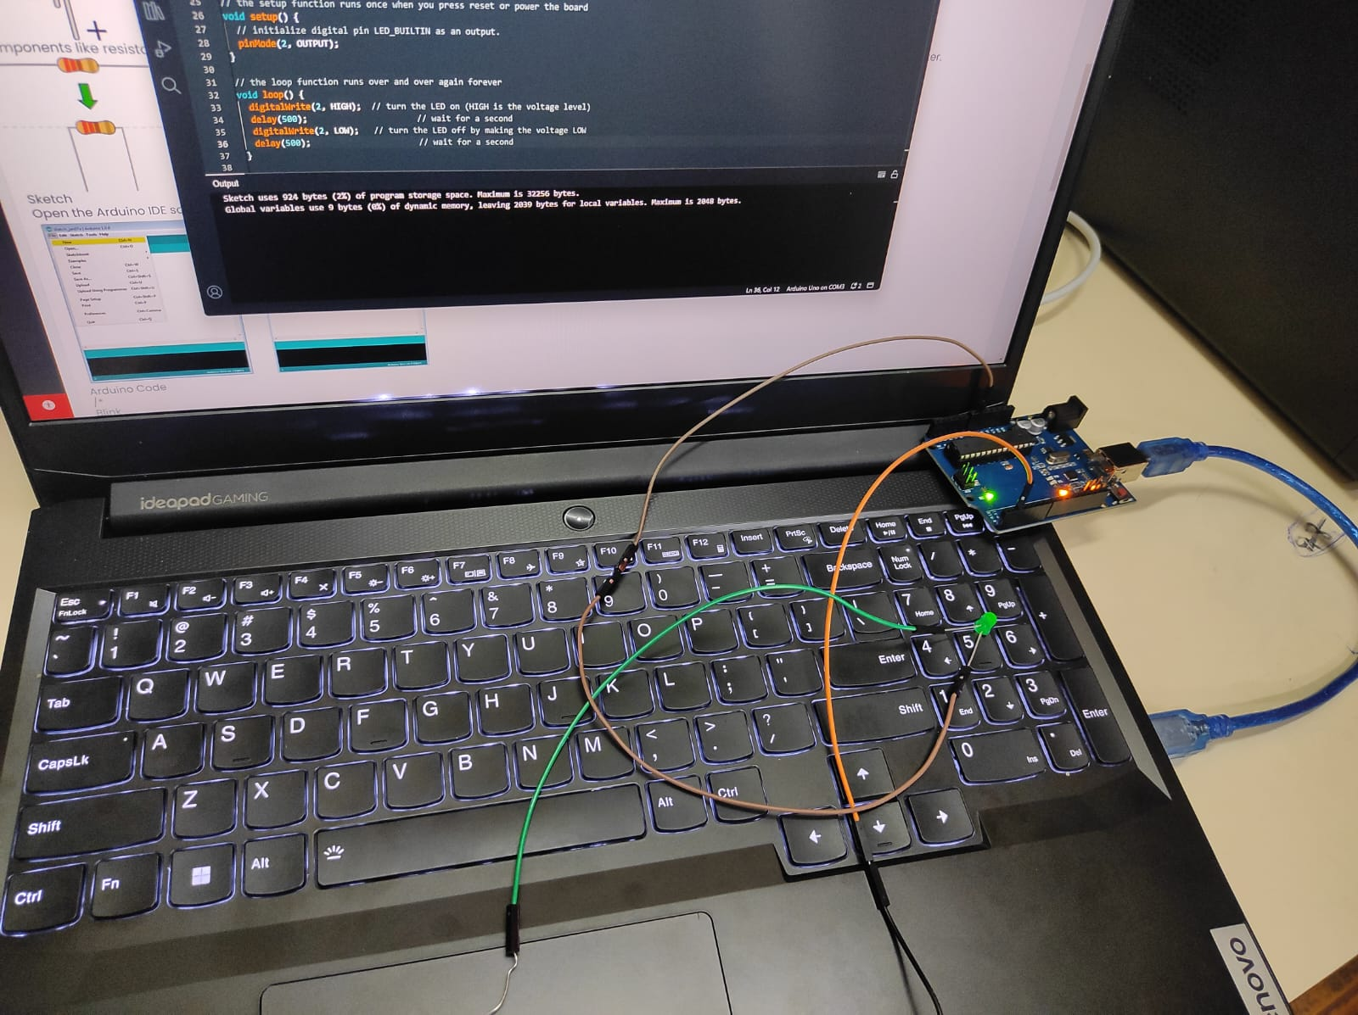

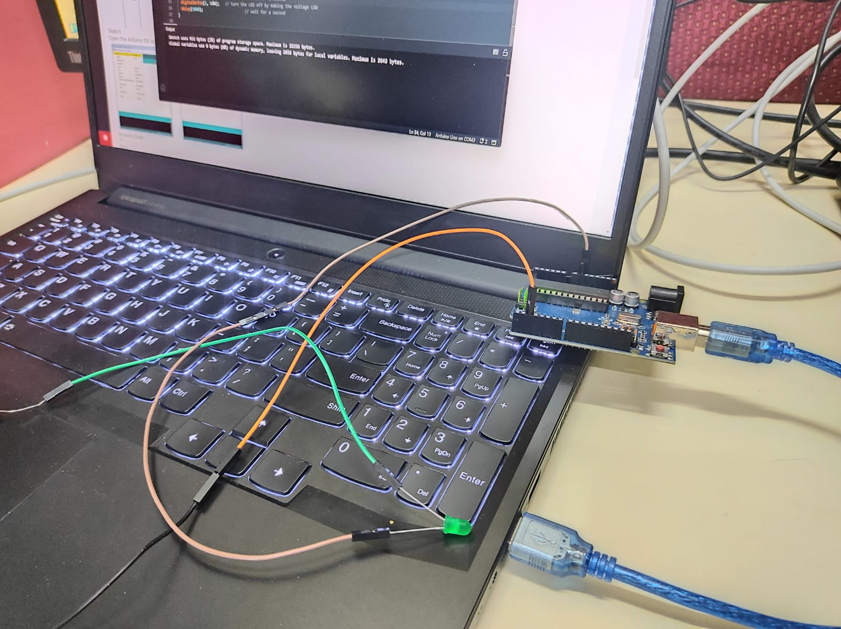

**Learning outcomes (What I have learnt):**

* Learnt about interfacing.
* Learnt about IoT programming.

**Evaluation Grid (To be created as per the SOP and Assessment guidelines by the faculty):**

|  |  |  |  |
| --- | --- | --- | --- |
| Sr. No. | Parameters | Marks Obtained | Maximum Marks |
| 1. |  |  |  |